Chapter 17, Problem 54.

Find the exponential Fourier series for the function in Fig. 17.81.

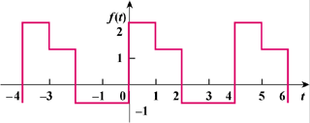

Figure 17.81
For Prob. 17.54.

